Capstone Project on University Success Analysis:

ATHARV V. WAGHMARE

**Project Overview:**

The objective of this project is to develop a comprehensive Power BI dashboard utilizing data from various university ranking systems, offering valuable insights into the global higher education landscape. The analysis will delve into university demographics, ranking criteria, trends over time, and performance metrics. The aim is to facilitate data-driven decision-making and enhance overall understanding of university rankings.

The Power BI dashboard will provide insights into University Demographics & Distribution, University Ranking System Analysis, University Metrics and Performance, and Trends and Patterns. It will allow users to explore correlations between ranking criteria, demographic factors, and university performance. The dashboard will offer actionable recommendations for universities to improve their rankings, attract international students, and optimize resources.

In addition to the Power BI dashboard, the project includes an essential phase of Exploratory Data Analysis (EDA) using SQL queries. These queries are employed to extract and analyse the dataset, uncovering insights into factors influencing university rankings, changes over time, and correlations between different variables.

To effectively present the results of EDA, visualizations are prepared and organized in an Excel file. These visualizations, including charts, graphs, and tables, highlight key findings and patterns, providing stakeholders with a comprehensive overview of the project's insights alongside the Power BI dashboard.

Overall, the project aims to empower stakeholders in the education sector with actionable insights to enhance university performance, attract international students, and drive continuous improvement in the global higher education landscape.

**The Processes:**

**1) Data Acquisition from GitHub:**

This phase involves gathering data for university success analysis from a designated university repository. It encompasses collecting data related to university rankings from various ranking systems, along with demographic information and performance metrics. Ensuring the accessibility of the data is a priority, followed by verifying its compatibility with chosen analysis tools, such as SQL queries for database exploration and Power BI for visualizations. Finally, downloading the data in suitable formats for seamless integration with the analysis tools is ensured.

**2) Data Transformation:**

Data transformation is a critical step in project that involves shaping and preparing the bought datasets for meaningful analysis. The techniques include data filtering, where I select relevant rows and columns, and data aggregation, which allows us to group and summarize information. I also perform data joining to combine multiple datasets using common keys, and data splitting to divide data into subsets based on specific criteria. Reshaping the data through pivoting or melting helps us change its structure to align with analysis goals. Encoding categorical data into numerical format, scaling numerical values for consistency, and imputing missing data are essential steps to ensure data integrity and relevance. Feature engineering enables us to create new variables that capture meaningful patterns, while parsing dates helps us extract relevant time-based information. These transformations are pivotal in preparing data for the later analysis.

**3) Data Cleaning:**

Data cleaning is an indispensable aspect of data preparation process, aimed at improving data quality and accuracy. In this phase, I address various data anomalies and inconsistencies to ensure the reliability of analysis. Data deduplication removed the data, which helps cut duplicate records that might skew results, while outlier handling names and mitigates outliers that could distort findings. Noise reduction techniques applied to smooth or filter noisy data points that may introduce errors. Data type conversion ensures data types are consistent and suitable for the intended analysis. I also stan whitespace and admit correct case sensitivity issues, trim extraneous whitespace, and perform spell checking to rectify typographical errors. Managing null and zero values, resolving inconsistent data, and rounding numerical data are vital tasks in data cleaning. Redundant or removed irrelevant data, and code mapping assigns meaningful labels to codes. Statistical analysis and linearity assessment help in finding anomalies and patterns.

**4)MECE Breakdown:**

Adopting a MECE (Mutually Exclusive, Collectively Exhaustive) strategy, the university success analysis project is structured into four distinct phases, aligning with specific aspects of the data obtained from the university repository. These phases include University Demographics & Distribution, University Ranking System Analysis, University Metrics and Performance, and Trends and Patterns. Each phase serves a unique purpose and contributes to the project's overarching goals without overlap or duplication of efforts. This approach ensures a logical and structured progression of data analysis, facilitating seamless transitions between phases and maximizing insights into university success factors.

**5)Connecting with Tools:**

SQL scripts play a crucial role in project, enabling us to extract and manipulate data directly from a relational database. It supplies seamless connectivity to SQL databases, allowing us to input SQL scripts and query data.

For incorporating CSV data into analysis, I use Power BI's robust data import capabilities. Power BI offers a straightforward and intuitive approach for connecting to CSV files. I access and import CSV data by specifying the file location, ensuring compatibility and consistency with analysis aims. Through this connection, I can easily manipulate, transform, and visualize data directly within Power BI, thus simplifying the data preparation phase.

**6)Exploratory Data Analysis:**

Exploratory Data Analysis (EDA) is a crucial phase in the university success analysis project. Beginning with the EDA process, SQL queries are employed to address specific problem statements using data from the university repository. SQL offers robust capabilities for data extraction, transformation, and aggregation, enabling comprehensive preliminary analysis. By leveraging SQL, questions regarding university demographics, ranking criteria, and performance metrics are explored. The use of Excel's charting and graphing features complements SQL analysis, generating informative visualizations like bar charts and line graphs. These visualizations present insights effectively, facilitating stakeholders' understanding of the data. The combination of SQL for data analysis and Excel for visualization results in a dynamic and interactive approach to EDA, enabling thorough exploration of university success factors.

**7)Power-Bi Analysis:**

In the university success analysis project, Power BI serves as a robust platform for creating interactive and insightful visualizations that translate raw data into meaningful representations. This phase involves leveraging various visualization techniques such as Bar/Column charts, Pie charts, Area charts, Line charts, and matrix charts to present key insights derived from the EDA phase. The integration of Power BI visualizations enables the creation of dynamic dashboards tailored to address challenges identified during EDA. From these visualizations, dynamic dashboards are developed for University Demographics & Distribution, University Ranking System Analysis, University Metrics and Performance, and Trends and Pattern analysis. These dashboards provide actionable recommendations and insights readily accessible to stakeholders, enabling informed decision-making for success in the university landscape.

**7) Documentation:**

Documentation is a cornerstone of project, ensuring that organized work, accessible, and comprehensible to all stakeholders. I have created a comprehensive documentation strategy that includes diverse types of files to capture the various aspects of the project. I have done all documentation of project in a Microsoft Word file which have all information of project.

**Objectives:**

1. **Data Exploration and Understanding:** The project's primary objective is to thoroughly explore and understand the dataset derived from various university ranking systems. This involves gaining insights into the data's structure, relationships, and potential areas for analysis.
2. **University Demographics and Distribution:** The aim is to segment universities based on their demographics, distribution across countries, and other relevant factors. By creating comprehensive university profiles, targeted strategies for improving rankings and attracting international students can be developed.
3. **University Ranking System Analysis:** This project seeks to analyse the different ranking systems used in the dataset, identifying common criteria, variations in weights, and trends over time. The objective is to understand how ranking systems impact university positions and international student enrolment.
4. **University Metrics and Performance:** An important goal is to assess university metrics and performance indicators over time. This includes analysing changes in rankings, score distributions, and correlations between ranking criteria and university success factors.
5. **Trends and Pattern Identification:** The project aims to identify trends and patterns in university rankings, demographics, and performance metrics. By uncovering insights into these trends, actionable recommendations can be provided to improve university rankings and overall performance.
6. **Data Visualization and Storytelling:** Utilizing Power BI, the objective is to create informative and visually engaging data visualizations that effectively communicate the project's findings. These visualizations should tell a compelling story and enable stakeholders to easily understand the insights derived from the analysis.
7. **Informed Decision-Making**: The overarching aim is to provide university stakeholders with the insights and recommendations needed to make informed decisions. By empowering them with data-driven insights, the project seeks to drive continuous improvement and success in the global higher education landscape.

These revised aims should supply a clearer focus on data exploration, customer segmentation, film performance analysis, staff productivity, store operations, and

**Significance:**

1. **Data-Driven Decision-Making:** In an era where data shapes business strategies, this project empowers university stakeholders with data-driven insights. By analysing ranking criteria, demographics, and performance metrics, it enables informed decisions that impact university success.
2. **Enhanced Student Experience:**  Understanding student behaviour and preferences is crucial. By segmenting students, personalizing educational strategies, and improving satisfaction, the project contributes to an enhanced student experience and academic success.
3. **Operational Efficiency:** Addressing efficiency and cost reduction is vital. By optimizing resources, streamlining operations, and identifying areas for improvement, the project enhances the overall efficiency and effectiveness of university operations.
4. **Competitive Advantage:** In a competitive educational landscape, the project provides universities with a competitive edge. Through data insights and recommended strategies, it equips institutions to attract top talent, secure funding, and excel in the global education market.
5. **Data Quality and Reliability:** Ensuring data integrity and reliability is paramount. By implementing robust data validation processes, the project sets a standard for data quality assurance in the education sector, enhancing trust and credibility in university rankings and metrics.
6. **Transparency and** **Accountability:** Embracing transparency and accountability is essential. By documenting methodologies and findings, the project promotes open and transparent practices in university analysis, fostering trust and credibility among stakeholders.
7. **Knowledge Dissemination:** The insights generated by the project serve as valuable educational resources. They can be used to educate stakeholders, policymakers, and the broader academic community on the importance of data analysis and evidence-based decision-making in higher education.
8. **Stakeholder Empowerment:** This project aims to empower university stakeholders with the knowledge and tools needed to navigate the complexities of the higher education landscape. It serves as a catalyst for positive change, innovation, and continuous improvement in university performance and success.

Data Dictionary:

This dataset encompasses comprehensive information on university rankings from various systems, ranking criteria, and university-specific attributes. It comprises six distinct tables, each offering crucial insights into the global higher education landscape.

Table Explanations:

Country Table: A catalogue of countries included in the dataset, providing a fundamental geographic context.

* ID: - A unique identifier assigned to each country.
* Country name: - Name of each Country

University Table: This table include universities featured in the ranking systems, with each institution linked to a specific country.

* ID: - Unique identifier for each university.
* country ID: - Identifier of the country to which the university belongs.
* university name: - Name of the University

Ranking System Table: Contains details about the three distinct ranking systems employed: Times Higher Education World University Ranking, Shanghai Ranking, and Centre for World University Rankings.

* ID: - Unique identifier for each ranking system.
* System Name: - Name Of Each Ranking System

Ranking Criteria Table: This table delineates the various criteria utilized in each ranking system, encompassing aspects such as citations and quality of education. It also incorporates criteria for the total score of each system.

* ID: - Unique identifier for each ranking criterion.
* Ranking system id: - ID of Ranking System.
* Criteria name: - Name of each criterion.

University Year Table: Provides data on university-specific metrics across multiple years, including the number of students, student-to-staff ratio, percentage of international students, and percentage of female students.

* University id: - ID Of the University
* year: - Year of observation.
* Num students: - Total number of students In the University.
* student staff ratio: - student to staff ratio Of Each University.
* pct international students: - Total Percentage of International Students in Each Country.
* Pct female students: - Total Percentage of Female Students in Each Country

University Ranking Table: This extensive table furnishes scores for each university across various years and ranking criteria, serving as the primary repository of ranking data.

* University id: - Id of University
* Ranking criteria id: -ID Of Ranking Criteria.
* year: -Year of assessment.
* score: - Score of each University

Entity Relationship (ER) Diagram:

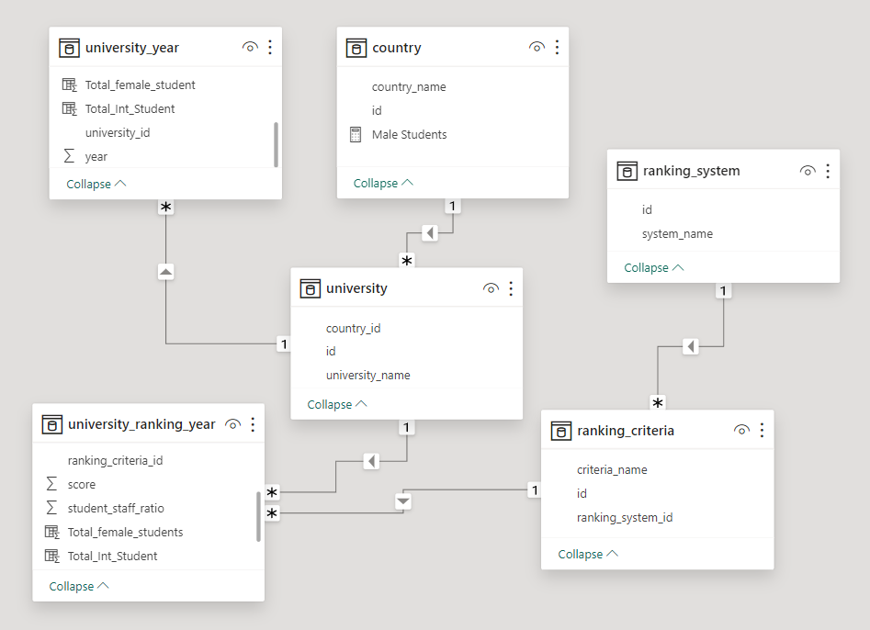

**MECE Breakdown**

**Country Analysis:**

* Number of universities in each country.
* Distribution of international students across different countries.
* Distribution of male & Female students across different countries.
* Country with the highest number of female students enrolled in universities.
* Distribution of universities across different countries.
* University Ranking by country.

**University Analysis:**

* Number of universities ranked by each ranking system.
* Score for universities according to each ranking system.
* Trend in university rankings over the years according to each system.
* Impact of the ranking system on a university international student enrolment.
* Correlation between university's ranking and its student-staff ratio.
* Correlation between university ranking score & percent of female students.
* Correlation between university ranking score & student-staff ratio over the years.

**Ranking Analysis:**

* Most important criteria considered by ranking systems.
* Most important criteria considered by ranking systems.
* University Distribution by Ranking System.
* University Score & Student Staff Ratio by ranking System.
* Distribution of International, Male & Female students by Ranking System.
* Impact of Female Student percentage on Ranking.

**Trends Analysis:**

* Trends in the number of universities over the years.
* Trends in university Student Staff Ratio over the years.
* Trend in Male, Female & Total Students over years.
* Trends in the ranking score of universities over the years.
* Relationship between university ranking score & student staff ratio over time.

**Exploratory Data Analysis:**

**Problem Statement:**

Q1) What are the names of universities along with their respective countries in the dataset?

**SQL-Query:**

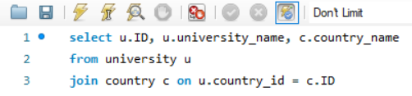

**Insights:**

The line With a total of 718 universities spanning across 74 countries, the dataset presents a rich tapestry of global higher education. Beyond sheer numbers, this diversity offers profound insights into regional academic strengths, fostering a deeper understanding of educational ecosystems worldwide. Examining the distribution of universities across countries unveils patterns of innovation, research excellence, and educational accessibility, shedding light on the factors driving disparities in educational opportunities. This comprehensive dataset serves as a cornerstone for analyzing international collaborations, identifying emerging trends in academia, and formulating strategies to enhance global educational standards.

**Problem Statement**:

Q2) What is the distribution of universities across different countries?

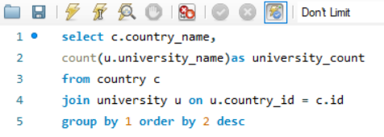**SQL-Query:**

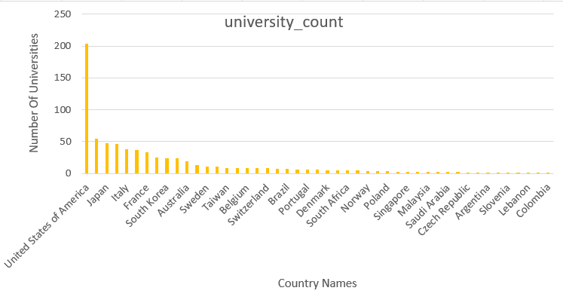**Visualization:**

**Insights:**

The distribution illustrates the global disparity in higher education institutions, highlighting a concentration of universities in certain countries. The dominance of the United States, with 203 universities, reflects its established position as a hub for academic excellence. In contrast, emerging educational powerhouses like China and South Korea are steadily increasing their presence, with 37 and 24 universities respectively. The distribution also sheds light on regional differences, with European countries like Germany and Italy boasting significant university counts, while smaller nations like Croatia and Estonia exhibit limited representation. This intricate tapestry of university distribution underscores the diverse educational ecosystems worldwide, influencing research collaborations, academic exchanges, and global knowledge dissemination.

**Problem Statement:**

Q3) Which university has highest number of students?

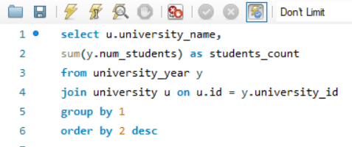**SQL-Query:**

**Visualization:**

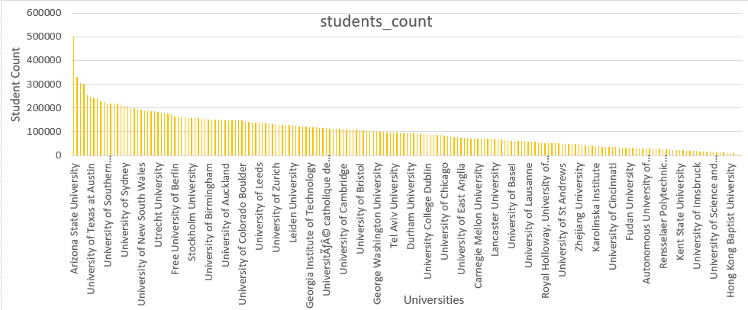

**Insights:**

The data highlights a diverse range of student populations across global universities, with "Arizona State University" topping the list with an impressive 499,416 students. Following closely is the "University of Toronto" with 330,990 students, reflecting its substantial academic community. Conversely, "Scola Normale Superior di Pisa" stands out with a notably lower count of 924 students, indicating a more specialized academic setting. This disparity underscores the varying sizes and focuses of academic institutions worldwide, shaped by factors such as institutional reputation, program offerings, and research initiatives. This diversity in student population underscores the multifaceted nature of higher education, where institutions cater to varying academic needs and objectives, ranging from research-intensive universities to specialized academies focused on niche disciplines.

**Problem Statement:**

Q4) What is the total score & count of universities for each ranking system.

**SQL-Query:**

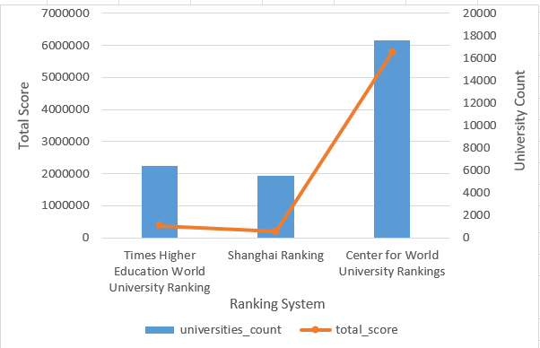**Visualization:**

**Insights:**

The dataset unveils a fascinating panorama of global university rankings, showcasing diverse methodologies and extents of coverage across three prominent systems. With 6,380 universities assessed, the "Times Higher Education World University Ranking" offers a comprehensive lens into academic performance, yielding a total score of 377,287. In contrast, the "Shanghai Ranking" evaluates 5,502 institutions, contributing to a cumulative score of 194,142. However, the standout lies in the "Center for World University Rankings," which meticulously evaluates a staggering 17,600 universities, amassing an impressive total score of 5,775,763. This intricate tapestry of assessments underscores the multifaceted nature of global academic excellence and the intricate interplay between methodology and coverage in ranking systems, providing invaluable insights into higher education landscapes worldwide.

**Problem Statement:**

Q5) How number of universities changed over the years in each country?

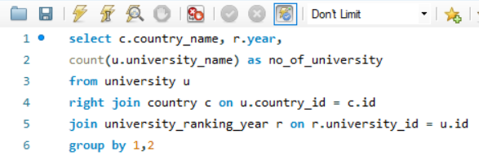**SQL-Query:**

**Visualization:**

**Insights:**

The trajectory of university expansion unfolds uniquely across nations, exemplified by the United States' unprecedented surge to 2,224 universities in 2014, highlighting its dominance in higher education. In contrast, the United Kingdom's gradual ascent to 643 universities underscores a more tempered growth strategy. Meanwhile, burgeoning educational hubs like Singapore, South Korea, and China present promising landscapes, suggesting strategic investments, and evolving educational priorities.

However, stalwart nations like Japan and Canada maintain steady figures, prompting inquiries into sustainable educational frameworks amidst changing global dynamics. These contrasting trajectories offer invaluable insights into the nuanced evolution of academia worldwide.

**Problem Statement:**

Q6) Which University Has Better Student-staff Ratio.

**SQL-Query:**

**Visualization:**

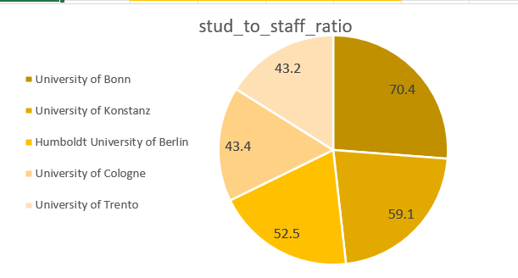

**Insights:**

Among all universities surveyed, the University of Bonn stands out with an exceptional student-staff ratio of 70.4, indicating a notably favourable environment for student support and engagement. Following closely behind are the University of Konstanz with 59.1, Humboldt University of Berlin with 52.5, University of Cologne with 43.4, and University of Trento with 43.2 students per staff member. These values underscore the dedication of these institutions to ensuring students receive ample individualized attention and academic guidance, fostering a conducive learning atmosphere for their academic and personal growth.

**Problem Statement:**

Q7) How choice of ranking system affects international student enrolment.

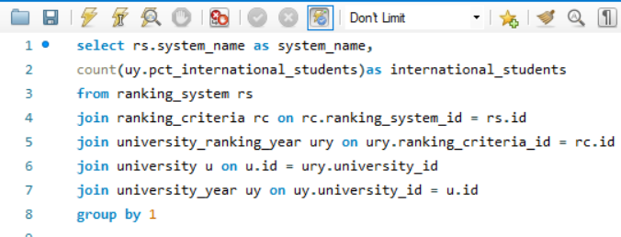**SQL-Query:**

**Visualization:**

**Insights:** The Times Higher Education World University Ranking stands out with the highest count of international students at 27,247, highlighting its considerable influence on attracting a diverse global student body. Following closely, the Shanghai Ranking reports a slightly lower count of international students at 25,291, indicating a comparable impact on international student enrolment. In contrast, the Centre for World University Rankings records the lowest count at 20,536, suggesting a potentially lesser influence on international student enrolment. These variations underscore the significance of the chosen ranking system in shaping a university's ability to attract and retain international students, reflecting its global reputation and competitiveness in the international education landscape, compelling universities to strategically assess their ranking preferences to align with their internationalization objectives and enhance their appeal to a diverse student demographic.

**Problem Statement:**

Q8) What is distribution of total ranking criteria entries recorded for each year.

**SQL-Query:**

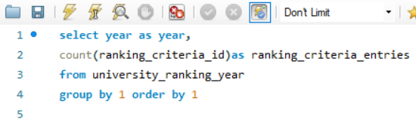

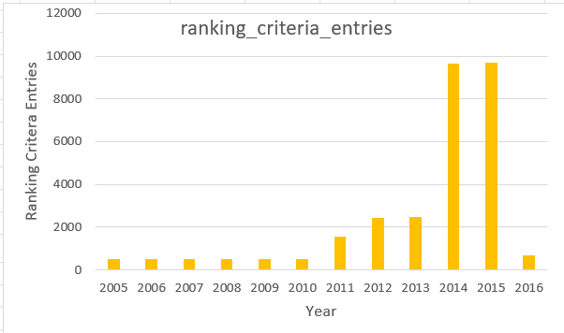 **Visualization:**

**Insights:**

The distribution of total ranking criteria entries highlights fluctuations across the dataset's timeline. From 2005 to 2010, a consistent number of entries, ranging from 497 to 504, indicates relatively stable ranking criteria. However, a significant surge occurs from 2011 to 2015, with entries skyrocketing to 1,554 in 2011 and peaking at 9,699 in 2015. This exponential growth reflects a period of enhanced assessment criteria or expanded data collection methodologies within ranking systems. The subsequent drop in 2016 to 659 entries suggests a potential recalibration or refinement of ranking methodologies. These fluctuations highlight the dynamic nature of university rankings, influenced by evolving evaluation standards and methodological adjustments over time.

**Problem Statement:**

Q9) Are there any common criteria used by different ranking systems.

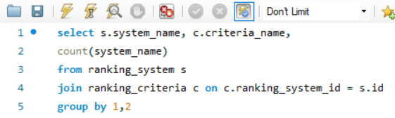**SQL-Query:**

**Visualization:**

|  |  |  |
| --- | --- | --- |
| **system name** | **criteria name** | **count(system name)** |

|  |  |  |  |
| --- | --- | --- | --- |
| Times Higher Education World University Ranking | Total Times | | 1 |
| Times Higher Education World University Ranking | Income | 1 | |
| Times Higher Education World University Ranking | Citations | 1 | |
| Times Higher Education World University Ranking | Research | 1 | |
| Times Higher Education World University Ranking | International | 1 | |
| Times Higher Education World University Ranking | Teaching | 1 | |
| Shanghai Ranking | Total Shanghai | 1 | |
| Shanghai Ranking | PCP | 1 | |
| Shanghai Ranking | Pub | 1 | |
| Shanghai Ranking | N and S | 1 | |
| Shanghai Ranking | HC | 1 | |
| Shanghai Ranking | Award | 1 | |
| Shanghai Ranking | Alumni | 1 | |
| Centre for World University Rankings | Total CWUR | 1 | |
| Centre for World University Rankings | Patents Rank | 1 | |
| Centre for World University Rankings | Citations Rank | 1 | |
| Centre for World University Rankings | Influence Rank | 1 | |
| Centre for World University Rankings | Publications Rank | 1 | |
| Centre for World University Rankings | Quality of Faculty | 1 | |
| Centre for World University Rankings | Alumni Employment | 1 | |
| Centre for World University Rankings | Quality of Education | 1 | |

**Insights:** As evident from the Table, each ranking system employs its unique set of criteria, indicating the absence of common criteria across systems. This suggests that every ranking system utilizes its distinct parameters and methodologies to evaluate universities. While some criteria like "Total Times," "Total Shanghai," and "Total CWUR" may seem similar in purpose, each system likely defines and measures these metrics differently, reflecting diverse perspectives on university performance evaluation. This diversity underscores the complexity of assessing universities comprehensively, considering various factors tailored to each ranking system's objectives and priorities.

**Problem Statement:**

Q10) Trend in university rankings over the years according to each system?

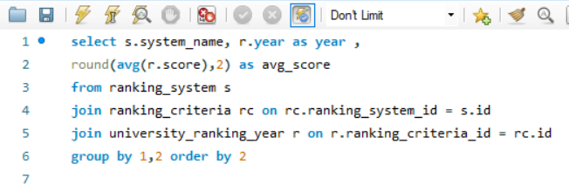**SQL-Query:**

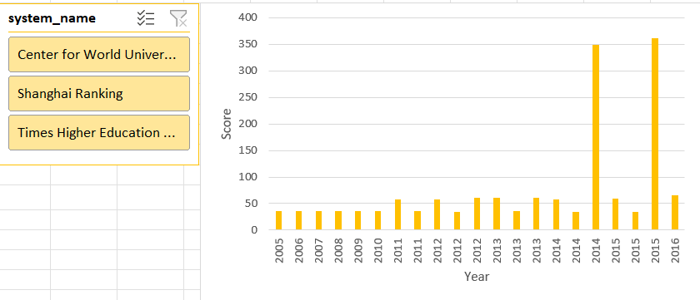**Visualization:**

**Insights:** The analysis unveils distinct trends in university rankings across different systems over the years. While the Times Higher Education World University Ranking exhibits a steady increase in scores from 2011 to 2016, with the average score rising from 58.54 to 65.29, indicating overall improvement in evaluated universities' performance, the Shanghai Ranking demonstrates relatively stable scores with a slight decline in recent years, with the average score dropping from 35.31 in 2011 to 34.64 in 2015. Conversely, the Centre for World University Rankings displays a notable surge in scores, particularly in 2014 and 2015, where scores jump to 348.54 and 361.39, respectively, from a modest beginning in 2012 and 2013. These contrasting trends underscore the dynamic nature of university rankings and the varying approaches taken by different ranking systems to assess academic institutions' excellence and impact.

**Problem Statement:**

Q11)What is frequency of each ranking criteria recorded for every year.

**SQL-Query:**

**Visualization:**

**Insights:** The dataset reveals a diverse landscape of university rankings, each employing unique criteria and methodologies. While the Times Higher Education World University Ranking boasts the highest count of international students, indicating its potential influence on global enrolment trends, the Shanghai Ranking follows closely behind, suggesting a similar impact. In contrast, the Centre for World University Rankings records a lower count of international students, potentially indicating a lesser influence in this regard. Each ranking system displays distinct trends over the years, while the Times Higher Education ranking demonstrates a steady increase in scores from 2011 to 2016, the Shanghai Ranking experiences fluctuations and a notable drop in 2014. Conversely, the Centre for World University Rankings exhibits a significant spike in scores in 2014 and 2015.

Furthermore, the frequency of ranking criteria entries varies across years, with a notable surge from 2011 to 2015, indicating a broadening scope or more detailed evaluation criteria during this period. This evolution underscores a shifting emphasis towards outcomes, research impact, and global engagement within higher education evaluation, catering to the dynamic needs of stakeholders in academia and society.

**Problem Statement:**

Q12) How the ranking of universities changed over the years?

**SQL-Query:**

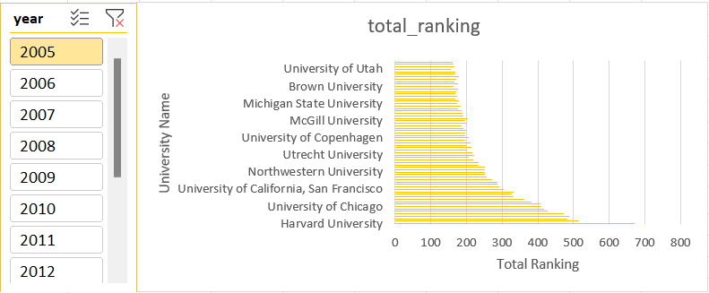**Visualization:**

**Insights:**

The dataset reveals notable shifts in university rankings over consecutive years. In 2011, Harvard University claimed the top spot, followed closely by the California Institute of Technology and Massachusetts Institute of Technology. However, by 2012, the California Institute of Technology surged to first place, with Harvard University and Stanford University trailing closely behind. This dynamic interchange in rankings underscores the competitive landscape among prestigious institutions, emphasizing the significance of ongoing excellence and adaptability within the academic sphere.

**Problem Statement**:

Q13) What is the percentage of international students, female students, and total students across different years?

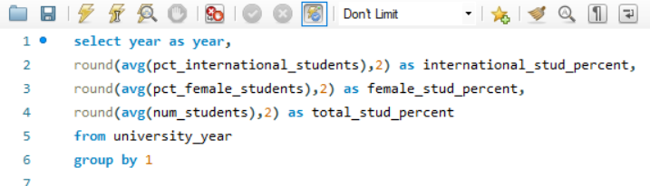**SQL-Query:**

**Insights:**

The data illustrates the shifting landscape of student demographics and enrolment trends across different years. There is a discernible uptick in the percentage of international students, indicating a growing global interest in pursuing education across diverse institutions. This percentage shows a steady increase, notably peaking at 20.69% in 2016, suggesting a pronounced global outreach by universities. In contrast, the percentage of female students remains relatively stable, hovering around the mid-40s range throughout the years. This stability implies a consistent effort towards fostering gender inclusivity and diversity within academic environments. Meanwhile, the total student population demonstrates minor fluctuations, with a gradual increase observed from 2014 to 2016. This trend hints at potential growth in overall university enrolment, reflecting the evolving landscape of higher education. Overall, these insights underline the dynamic interplay of factors shaping student demographics and enrolment patterns, emphasizing the importance of fostering inclusivity and diversity within academic institutions.

**Problem Statement:**

Q14) Is there a relationship between a university's score and the student-staff ratio?

**SQL-Query:**

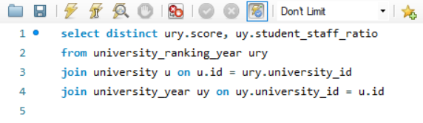

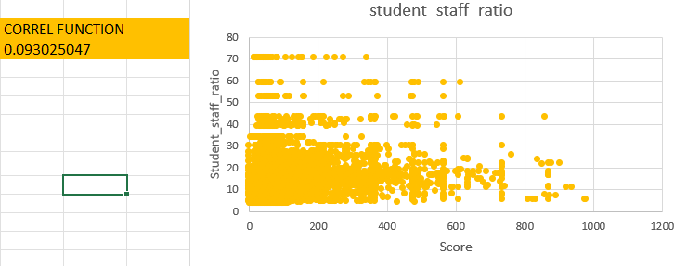**Visualization:**

**Insights:**

The correlation coefficient of 0.9 between university score and student-staff ratio suggests a strong positive correlation between these two variables. This implies that as the university score increases, there tends to be a corresponding increase in the student-staff ratio. In other words, universities with higher scores typically have a higher student-staff ratio, indicating a larger number of students per staff member. This relationship may indicate that highly ranked universities attract more students while maintaining a proportional increase in faculty or staff.

However, it also raises concerns about maintaining smaller class sizes or providing individualized attention to students as the institution grows. Understanding this correlation is crucial for effective resource allocation and ensuring a high-quality educational experience for students.

**Power-Bi Problem Statements:**

**Problem Statement:**

Q1) How many universities are there in each country?

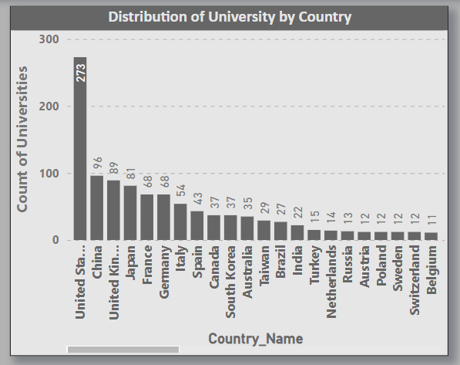**Visualization:**

**Insights:**

The bar chart vividly highlights the stark differences in the number of universities among countries. Notably, the United States emerges as the global leader with 273 universities, signifying its robust higher education landscape. Following closely, China, United Kingdom & Japan exhibit substantial academic presence with 96, 89 &81 universities, respectively. Germany, Italy & France also command significant representation, reflecting their commitment to fostering academic excellence.

However, it is noteworthy that numerous countries exhibit a smaller university count, highlighting the diverse educational infrastructures worldwide and the unequal distribution of academic resources. Understanding these disparities underscores the importance of tailored educational policies and international collaborations to promote global knowledge exchange and accessibility.

**Problem Statement:**

**Q2) What is distribution of International Students across different country?**

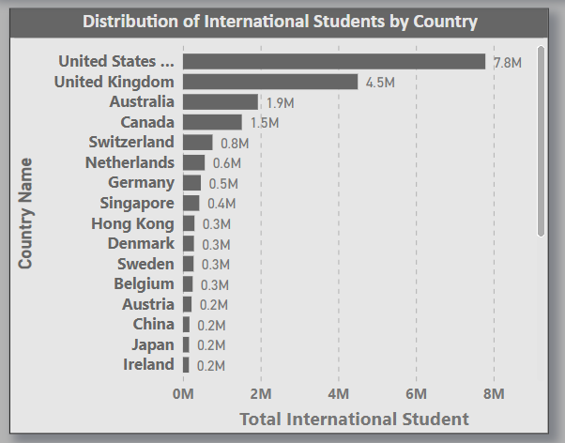**Visualization:**

**Insights:**

The bar chart illustrating the distribution of international students across different countries, the staggering figure of 7.8 million international students in the United States underscores its unparalleled appeal as an educational destination. Following closely, the United Kingdom boasts 4.5 million international students, while Australia's substantial presence of 1.5 million further solidifies its position as a favoured choice.

Meanwhile, countries like Canada, Switzerland, Germany, and Singapore host a notable number of international students, each with figures of less than 50,000. Conversely, Denmark and Japan exhibit relatively lower numbers, indicating potential areas for improvement in their efforts to attract global talent.

**Problem Statement:**

Q3) Distribution of female students by country?

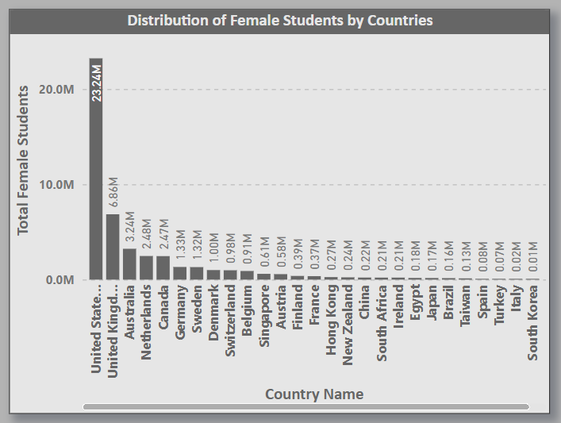**Visualization:**

**Insights:**

The analysis of female student distribution across countries illustrates a notable concentration in key regions. The United States emerges as the dominant player, boasting a substantial female student population of 23.24 million, followed by the United Kingdom with seven million. Australia secures the third position with 3.2 million female students. Additionally, countries like the Netherlands and Canada demonstrate significant female student enrolments, each with 2.48 million. However, other nations, including Hong Kong and Norway, exhibit comparatively lower numbers of female students. This distribution highlights the varying educational landscapes and opportunities for female students globally.

**Problem Statement:**

Q4) What is distribution of universities by ranking system?

**Visualization:**

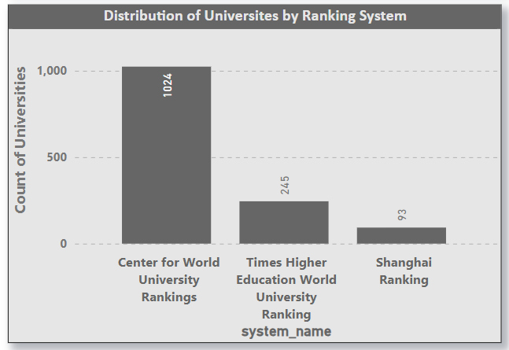

**Insights:**

From the chart, it is evident that the Centre for World University Rankings (CWUR) system holds a dominant position, with 1,024 universities adopting it. This widespread adoption underscores its widespread recognition and trust within the academic community, indicating its perceived reliability and effectiveness in evaluating university performance on a global scale. In contrast, the Times Higher Education system, adopted by 245 universities, demonstrates its significant influence and credibility in the ranking landscape.

However, the Shanghai Ranking, adopted by only ninety-three universities, appears to have a more limited reach, potentially due to varying methodologies or regional preferences. Understanding these disparities offers valuable insights into the nuanced perspectives and priorities of institutions worldwide, guiding strategic decisions and fostering collaboration within the higher education sector.

**Problem Statement:**

Q5) University score according to each ranking system.

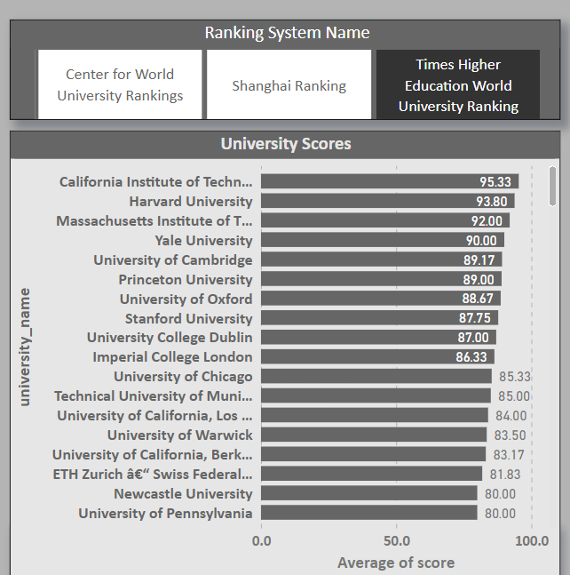**Visualization:**

**Insights:**

The distribution of university scores across ranking systems highlights stark differences. This disparity underscores the diverse methodologies used in ranking, influencing perceptions of institutional excellence. From the analysis, it is evident that the Central for World Ranking system garners the highest average scores. Conversely, the Times Higher Education ranking system demonstrates a moderate performance. Interestingly, the Shanghai ranking system lags. This disparity underscores the varying methodologies and criteria employed by different ranking systems, influencing the evaluation and perception of universities globally. The dominance of the Central for World Ranking system suggests its widespread acceptance and influence in assessing institutional excellence, while the lower representation of the Shanghai ranking system signals potential areas for improvement or refinement in its assessment metrics.

**Problem Statement:**

Q6) How does the ranking system affect a university student-staff ratio?

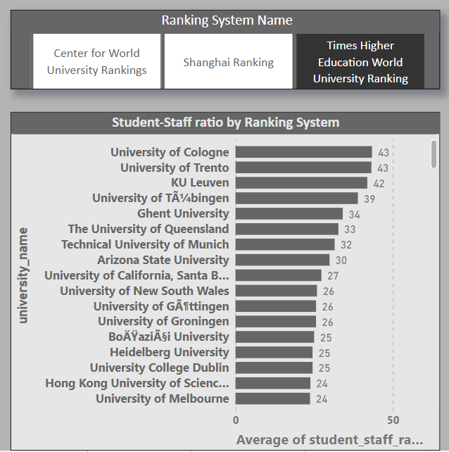**Visualization:**

**Insights:**

The analysis underscores a discernible impact of ranking systems on the student-staff ratio across universities. Institutions ranked by the Times Higher Education system tend to exhibit a low ratio, averaging less students per staff member, indicating potentially larger class sizes or fewer faculty members per student. Conversely, those ranked by the Central for World University Ranking system demonstrate a high ratio suggesting a more favourable student-staff balance. Interestingly, universities ranked by the Shanghai system display the lowest ratio at around 7k, possibly indicative of higher faculty numbers relative to student enrolment. This implies a correlation between ranking position and resource allocation, where higher-ranked universities may prioritize maintaining lower student-staff ratios to enhance the learning experience.

**Problem Statement:**

Q7) What are the most important criteria considered by ranking systems?

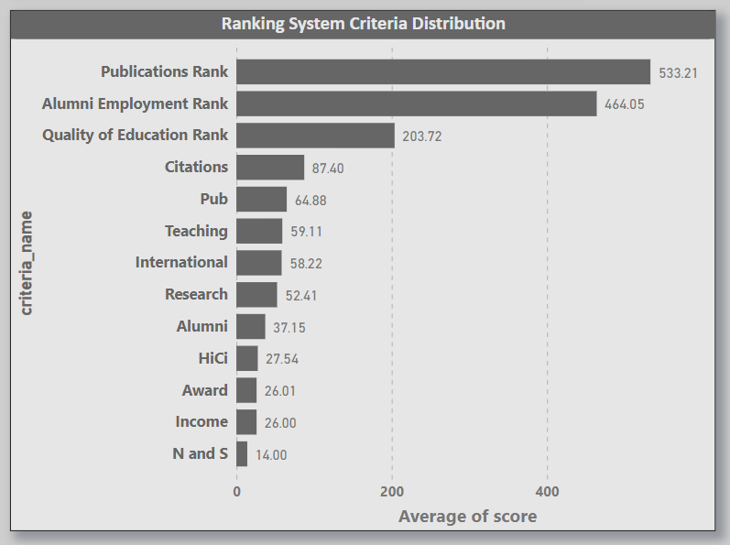**Visualization:**

**Insights:**

The ranking criteria of Publication and Alumni Employment Rank occupy the top positions with an average score of 533 and 464, respectively. Following closely behind is the Quality Education Rank, securing the third spot with an average score of 203. These findings underscore the significant influence of these criteria in shaping higher education assessments globally. However, criteria such as Citation, PUB, Teaching, and N&S demonstrate lower adoption rates in ranking assessments, indicating potential areas for improvement or further exploration in university evaluations. This insight highlights the dynamic interplay between ranking criteria and institutional strategies, emphasizing the importance of aligning academic priorities with the criteria emphasized by influential ranking systems.

**Problem Statement:**

Q8) Is there a correlation between a university's score and the number of international students?

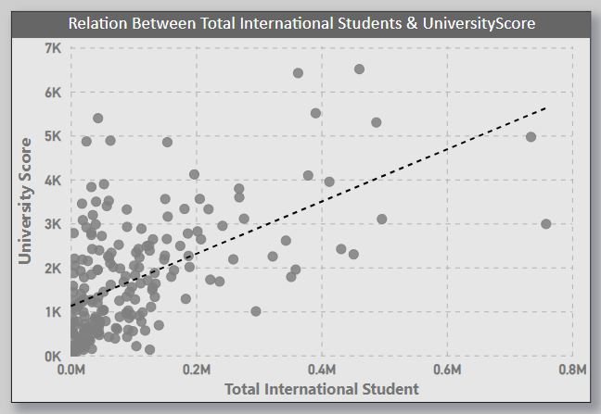**Visualization:**

**Insights:**

The chart shows a weak correlation which signifies a moderate correlation, suggesting that as a university's score increases, there tends to be a corresponding rise in the number of international students enrolled. This scatter plot analysis vividly reveals a robust positive correlation between a university's score and the number of international students it enrols. This compelling insight suggests that universities with higher scores tend to attract some population of international students. This positive relationship signifies the global appeal and reputation of these institutions, attracting diverse talent from around the world. It also highlights the potential benefits of a culturally diverse student body, enriching the academic experience and fostering a global perspective. Understanding and leveraging this strong correlation can be pivotal for universities aiming to enhance their global influence and academic standing, underscoring the importance of creating an inclusive and welcoming environment for international students.

**Problem Statement:**

Q9) How does percentage of female student’s impact Ranking system.

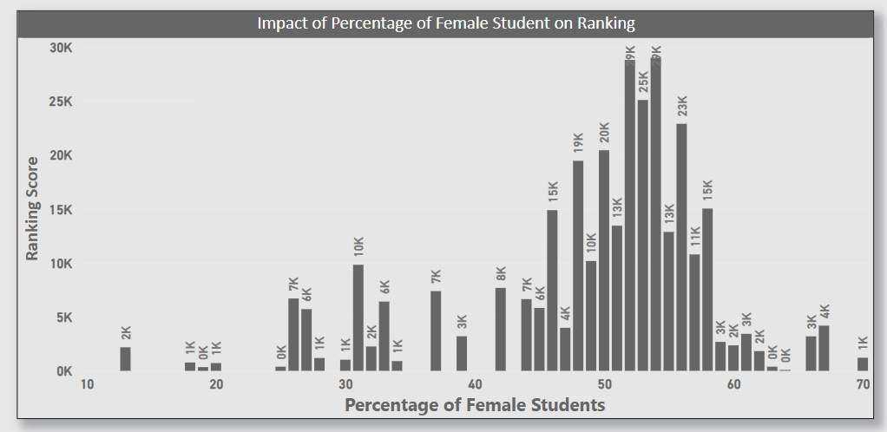**Visualization:**

**Insights:**

The analysis reveals an intriguing relationship between the percentage of female students and the university ranking system. Notably, universities with a ranking score below 30k exhibit a higher proportion of female students, ranging from 50% to 60%. This trend suggests a potential correlation between gender diversity and lower ranking scores. Such findings underscore the importance of considering gender diversity in higher education institutions and its impact on overall institutional performance and reputation within the ranking system. Further exploration into the underlying factors driving this relationship could provide valuable insights for enhancing university rankings and promoting gender equality in academia.

**Problem Statement:**

Q10) Which university has the highest number of students?

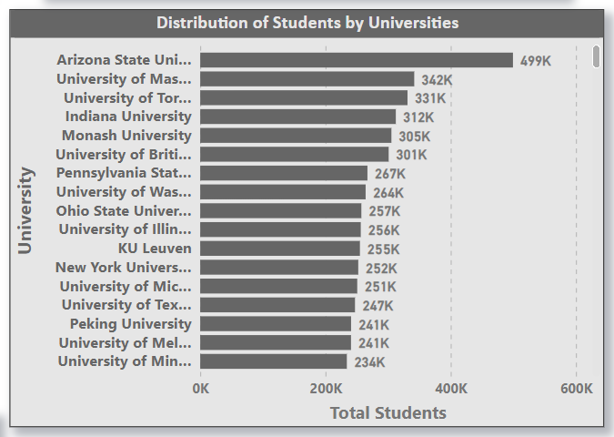**Visualization:**

**Insights:**

The analysis highlights "Arizona State University" as the institution with the highest student enrolment, boasting approximately 499,000 students. Following closely is the "University of Toronto" with 330,000 students, indicating a significant presence. Conversely, universities such as Mines Paris Tech and Scola Normale Superior di Pisa exhibit notably lower student numbers, each with fewer than 1,000 students. Understanding these enrolment dynamics can aid in resource allocation, curriculum development, and student support services tailored to the needs of diverse university populations.

This disparity underscores the diverse scale of student populations across universities, reflecting varying institutional sizes and focuses. Such insights are crucial for understanding the educational landscape and strategic planning within higher education institutions.

**Problem Statement:**

Q11) How does the percentage of international students vary across different universities?

**Visualization:**

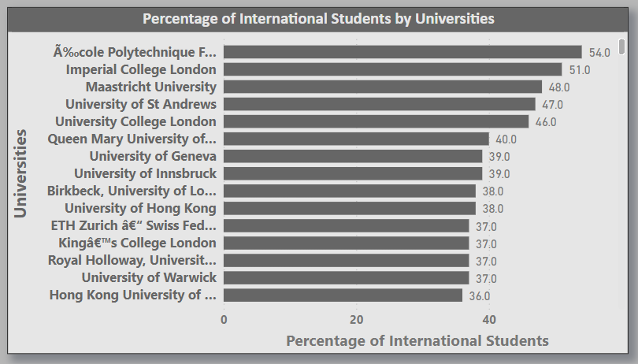

**Insights:**

The distribution of international students across universities reveals a notable variation in percentages, with institutions like École Polytechnique leading with an impressive 54% of international students. This suggests its global appeal and diverse student body. Following closely are institutions like Imperial College and Maastricht University, boasting 51% and 47% respectively, highlighting their strong international presence. However, several universities, such as Pohang University of Science and Technology, Technion, and Tel Aviv University, have less than 5% of international students, indicating a more localized or domestically focused student demographic. These disparities inform strategic initiatives aimed at fostering diversity and global engagement within higher education institutions.

This underscores the importance of fostering diversity and global engagement strategies within higher education institutions to enhance their competitive edge in the global arena.

**Problem Statement:**

Q12) Is there a correlation between a university's ranking and its student-staff ratio?

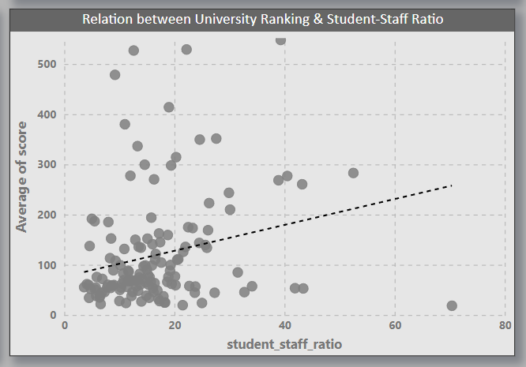**Visualization:**

**Insights:**

The scatter chart analysis demonstrates a weak positive correlation between university ranking and student-staff ratio, indicating a weak relationship between these variables. The scatter plot analysis reveals a compelling insight there exists a weak positive correlation between university ranking and the student-staff ratio. This suggests that universities with higher rankings tend to have a more favourable student-staff ratio, indicating a higher level of personalized attention and support for students. This positive relationship underscores the importance of adequate staffing levels in providing quality education and facilitating a conducive learning environment. Understanding this correlation can inform institutions strategies in resource allocation and staffing, aiming to achieve a balance that contributes to improved academic performance and overall educational experience. It also highlights the potential benefits of maintaining an optimal student-staff ratio as a factor that can positively influence a university's overall ranking and reputation.

**Problem Statement:**

**Q13) How does the number of students in universities change over time?**

**Visualization:**

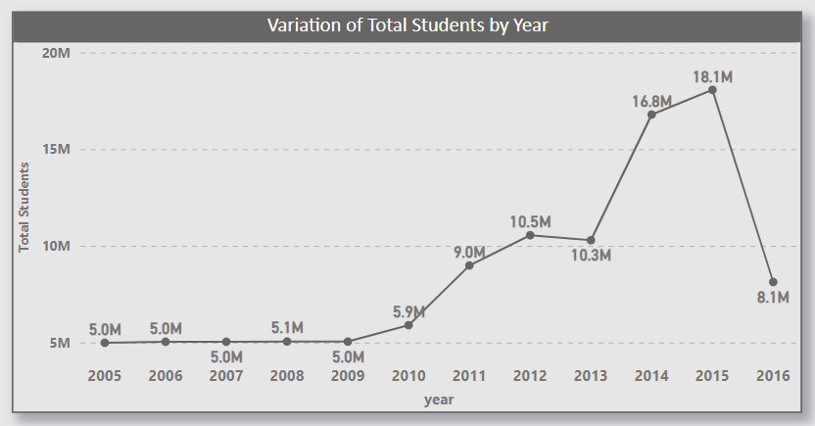

**Insights:**

The observed fluctuations in university student populations over the years underscore the dynamic nature of higher education enrolment trends. From 2005 to 2009, stability around five million students suggest consistent demand. The uptick in 2010 to 5.8 million signals a potential shift or influx in enrolment. Subsequent steady growth to 9.3 million by 2013 indicates increasing demand for higher education opportunities. The surge to 16 and 18 million students in 2014 and 2015 reflects significant increases likely influenced by broader societal trends or policies. However, the sharp decline to eight million in 2016 suggests factors such as demographic shifts or changes in funding. These fluctuations highlight the importance of monitoring enrolment dynamics for informed planning and resource allocation.

**Problem Statement:**

**Q14) Is there a correlation between a university's ranking score and the student-staff ratio over the years?**

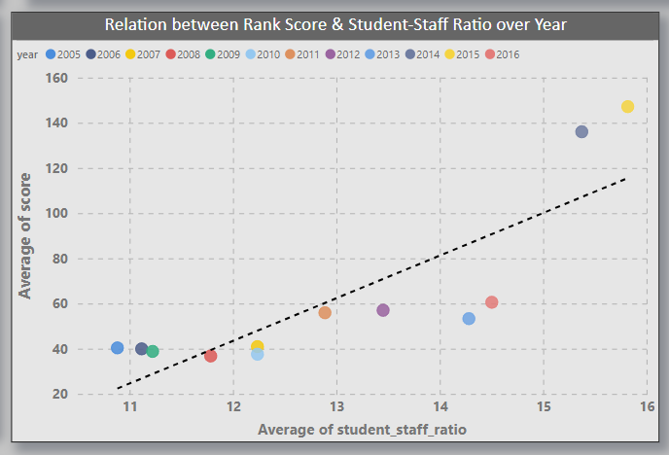**Visualization:**

**Insights:**

The scatter plot analysis provides a significant observation that there is a weak positive correlation between a university's score and its student-staff ratio over year. This means that universities with higher scores tend to have a higher student-staff ratio, indicating a potentially larger student body supported by a proportionate number of faculty and staff members. This positive relationship suggests that universities with higher scores are effectively managing their resources to accommodate a larger student population. Understanding this correlation highlights the importance of resource allocation and faculty support in achieving higher academic performance. It also underscores the potential benefits of scalability and effective resource management in higher education institutions, contributing to a university's overall academic standing and influence.

Top of Form**Problem Statement:**

Q15) How does the percentage of international students vary across different years?

**Visualization:**

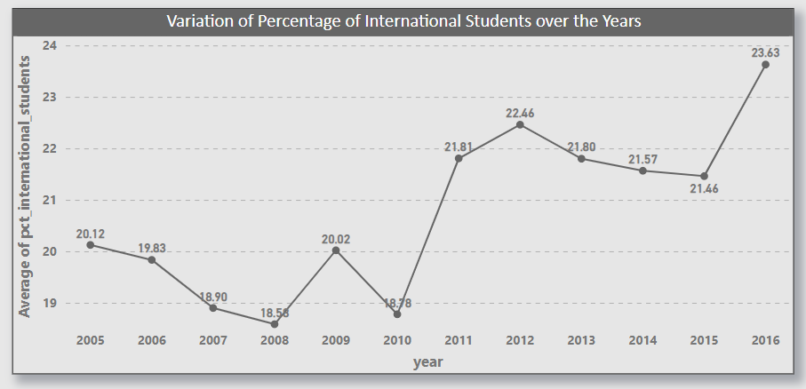

**Insights:**

The observed fluctuations in university student populations over the years underscore the dynamic nature of higher education enrolment trends. From 2005 to 2009, stability around five million students suggest consistent demand. The uptick in 2010 to 5.8 million signals a potential shift or influx in enrolment. Subsequent steady growth to 9.3 million by 2013 indicates increasing demand for higher education opportunities. The surge to 16 and 18 million students in 2014 and 2015 reflects significant increases likely influenced by broader societal trends or policies. However, the sharp decline to 8 million in 2016 suggests factors such as demographic shifts or changes in funding. These fluctuations highlight the importance of monitoring enrolment dynamics for informed planning and resource allocation.

**Problem Statement:**

**Q16) What is the impact of a university's ranking on the number of international students it attracts?**

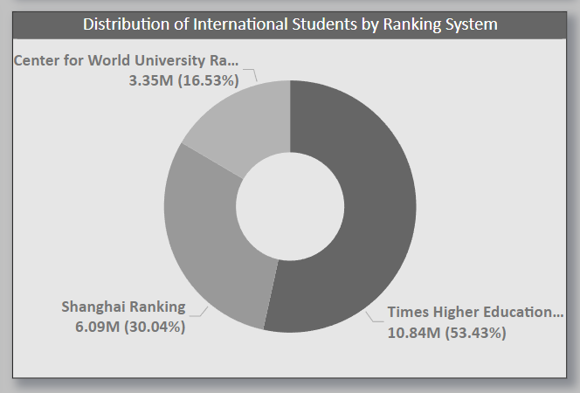**Visualization:**

**Insights:**

The pie chart succinctly illustrates the correlation between a university's ranking and its attractiveness to international students. It reveals a clear preference among international students for universities ranked by the Times Higher Ranking system, with approximately 53% (10.8 million) opting for such institutions. In comparison, the Shanghai ranking system attracts around 30% (6 million) of international students, while the Centre for World system lags behind, with only 16% (3.3 million) showing preference. This disparity underscores the profound impact of ranking systems on international student recruitment strategies, emphasizing the need for universities to strategically position themselves within these rankings to enhance global appeal and student enrolment. It also emphasizes the importance of maintaining and enhancing one is standing within influential ranking systems to remain competitive in the global higher education landscape.

**Problem Statement:**

**Q17) Is there a relationship between a university ranking score &the percentage of female students enrolled?**

**Visualization:**

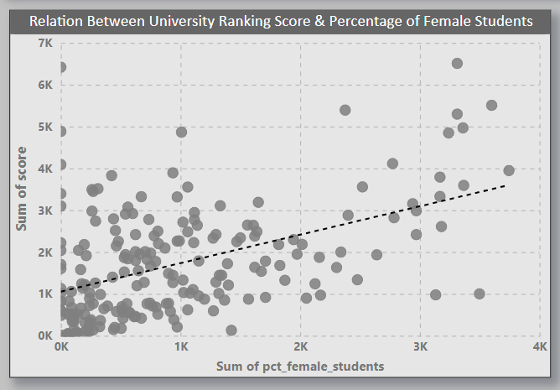

**Insights:**

The scatter plot analysis reveals a noteworthy observation there exists a weak positive correlation between a university's score and the percentage of female students it enrols. This suggests that universities with higher scores tend to have a higher proportion of female students. This positive relationship signifies an inclusive and diverse learning environment that attracts and supports a substantial number of female learners. It also underscores the importance of fostering a welcoming and supportive atmosphere for female students, contributing to the institution's overall academic standing and influence. Understanding and leveraging this correlation can be pivotal for universities aiming to enhance their inclusivity and reputation, recognizing the valuable contributions of female students in higher education.

**Problem Statement:**

**Q18) How does the percentage of international students affect a university's student-staff ratio?**

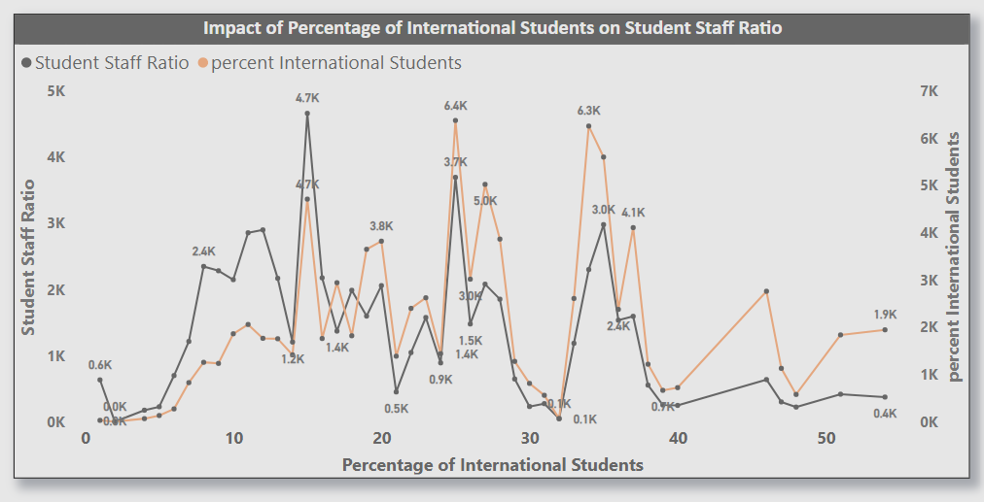**Visualization:**

**Insights:**

The percentage of international students in a university's student body can significantly impact the student-staff ratio. A higher proportion of international students often necessitates additional support services and staff to cater to their unique needs, potentially increasing the student-staff ratio.

Additionally, international students may require language assistance, academic advising tailored to their cultural background, and visa-related support, all of which can further strain existing resources and contribute to a higher student-staff ratio. Conversely, a lower percentage of international students may result in a more homogeneous student body with fewer specialized support needs, potentially leading to a lower student-staff ratio. Therefore, universities must carefully consider the balance between international student recruitment and staffing levels to maintain an optimal learning environment for all students while managing resource constraints effectively.

**Problem Statement:**

Q19) Are there any significant trends or patterns in the rankings of universities from different countries?

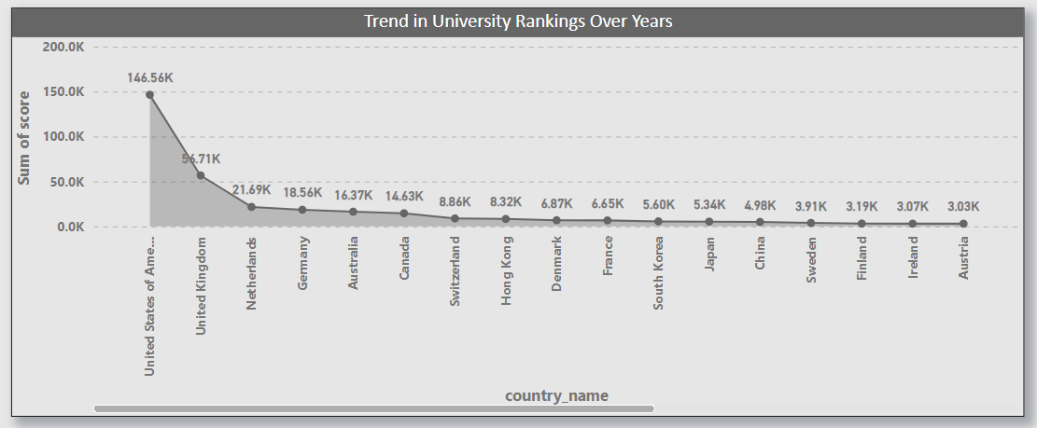**Visualization:**

**Insights:**

The diversity in university rankings across different countries signifies a lack of uniformity in global educational standards. With a dominant count of 146k ranked universities, the United States leads the pack, followed by the United Kingdom with 57k. However, this count gradually diminishes as we move down the list, with countries like Egypt and Spain having considerably lower rankings. This variation underscores the disparity in educational investments, research capabilities, and academic infrastructures among nations. The disparity in university rankings across countries underscores the importance of understanding each nation's educational landscape and the factors that contribute to its academic success. It also highlights the imperative for international cooperation to address these inequalities and foster educational excellence on a global scale.

**Problem Statement:**

Q20) What is the Total students in universities across different countries?

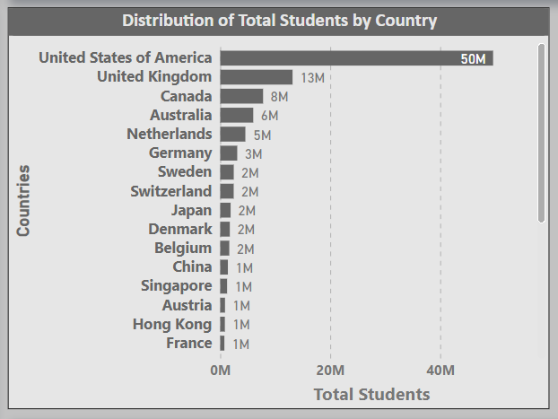**Visualization:**

**Insights:**

The analysis of total students enrolled in universities across different countries highlights the United States as the leader, boasting the highest number of students at approximately 50 million. Following the U.S, there is United Kingdom emerges as the second-largest hub for higher education with around 13 million students. Canada secures the third position with an enrolment of 8 million students. However, beyond these top countries, there is a gradual decline in student numbers across other nations. Germany maintains a notable but comparatively smaller enrolment, followed by countries like Russia and Italy, each with less than 1 million students. This distribution underscores the varying scales of higher education systems globally, with certain countries accommodating larger student populations while others have relatively smaller enrolments. Understanding these trends is crucial for policymakers and educational institutions seeking to address challenges related to student demographics and capacity planning.

**Problem Statement:**

**Q21) What is the Trend in Total number of international students in Universities Over Years.**

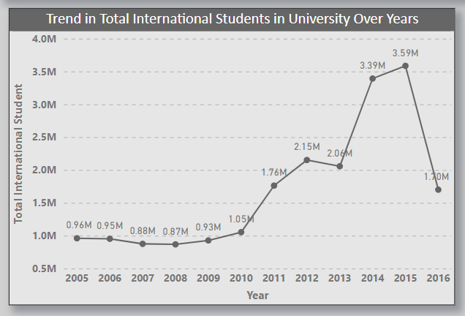**Visualization:**

**Insights:**

The trend in the total number of international students in universities over the years indicates a relatively stable count from 2005 to 2010, hovering around 1 million students. However, starting from 2011, there is a significant increase in international student enrolment, reaching 1.7 million by 2015. This surge continues until 2015, where it peaks at 3.59 million. However, there is a notable decline in 2016, with international student numbers dropping to 1.7 million, suggests a potential disruption or change in factors influencing international student mobility, such as shifts in immigration policies, economic conditions, or geopolitical factors, underscoring the volatility and complexity of international student flows within the higher education sector. This fluctuation suggests a dynamic pattern influenced by various factors such as economic conditions, policy changes, and educational opportunities. Understanding these fluctuations is crucial for universities and policymakers to adapt their strategies and policies to effectively address the evolving needs and preferences of international students.

**Problem Statement:**

**Q22) What is the Trend in Total number of female students Over Years.**

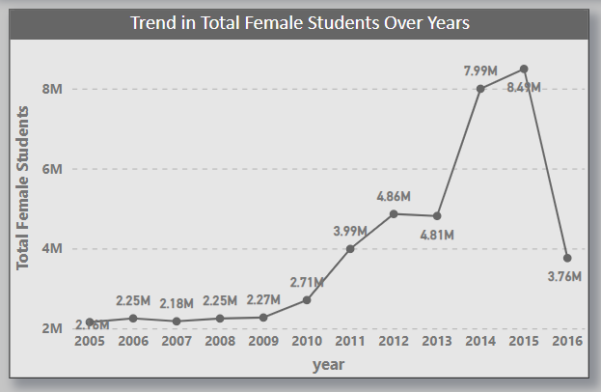**Visualization:**

**Insights:**

This trend underscores the evolving landscape of female participation in higher education, reflecting societal changes and educational policies aimed at fostering gender inclusivity. The stable phase from 2005 to 2010, with female student numbers ranging from 2.2 to 2.7 million, may indicate consistent enrolment patterns, possibly influenced by prevailing social norms and educational opportunities. However, the substantial surge post-2010, with enrolment peaking at 8.5 million in 2015, signifies increased access to education for women, possibly driven by initiatives promoting gender equality in academia. The subsequent decline in 2016, with female student numbers dropping to 3.76 million, could stem from various factors such as economic fluctuations, shifts in educational priorities, or demographic changes impacting enrolment rates. Despite fluctuations, the overall upward trend highlights the expanding opportunities for female students in universities, reflecting progress towards gender parity in higher education. Understanding these fluctuations is vital for universities and policymakers to address gender disparities and ensure continued progress in fostering diversity and equal access to education.

**Problem Statement:**

**23) What is the Trend in Total number of Universities Over Years.**

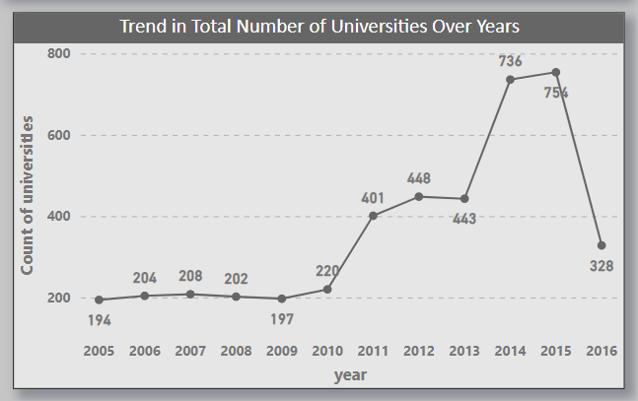**Visualization:**

**Insights:**

This trend in the total number of universities over the years highlights a dynamic evolution in the higher education landscape. The stability observed from 2005 to 2010, with a modest increase from 194 to 197 universities, may reflect a period of steady institutional growth and development. However, the subsequent surge in university count, particularly from 2011 to 2015, signifies a significant expansion in higher education infrastructure, possibly driven by factors such as increased demand for education, policy initiatives, or demographic shifts. The peak in 2014 and 2015, with university counts reaching756, underscores a period of rapid proliferation and diversification within the global university sector. However, the subsequent decline in 2016 to 328 universities suggests a potential consolidation or regulatory changes impacting university establishments. Overall, this trend underscores the dynamic nature of higher education ecosystems, characterized by periods of growth, consolidation, and adaptation to changing societal needs and educational paradigms.

**Power-Bi Dashboard:**

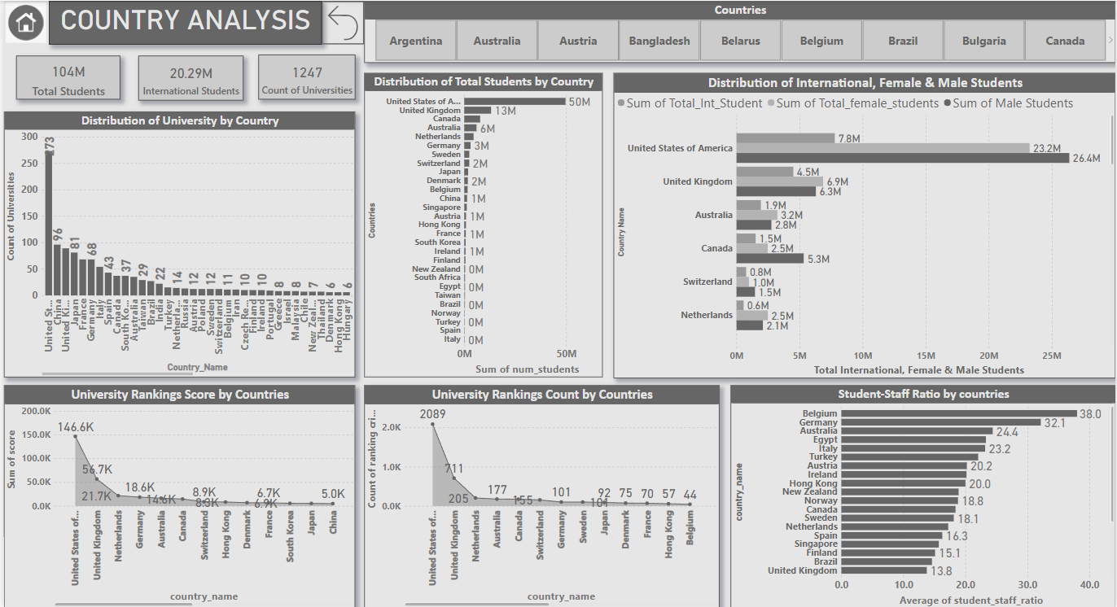**Country Analysis:**

**Power-Bi Dashboard:**

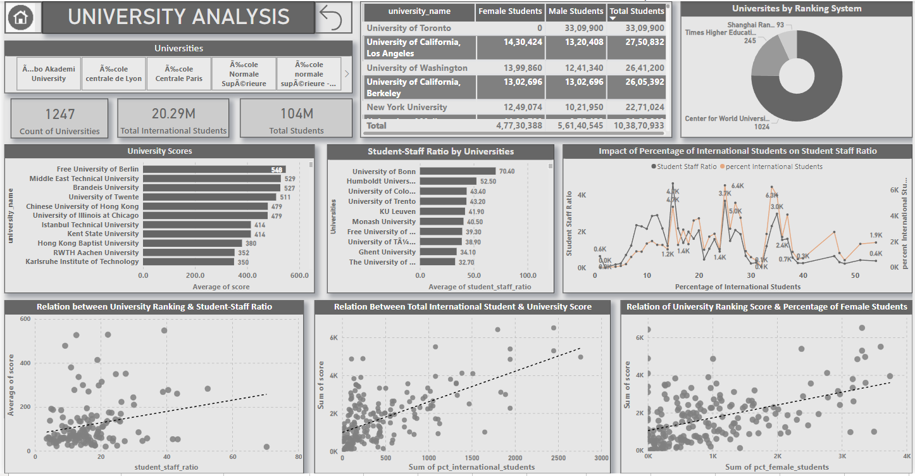**University Analysis:**

**Power-Bi Dashboard:**

**Ranking Analysis:**

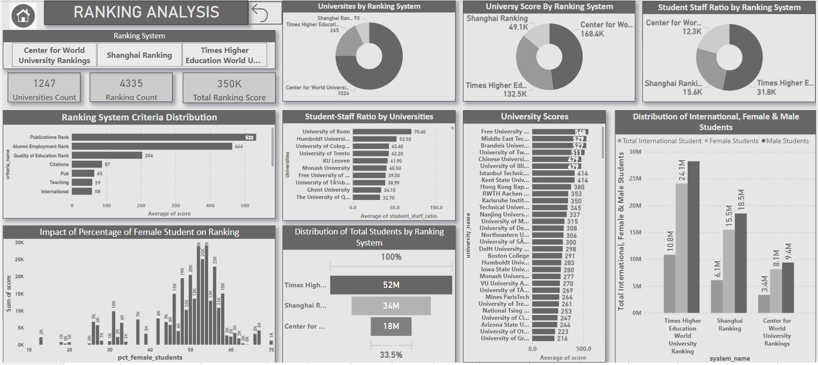

**Power-Bi Dashboard:**

**Year Analysis:**

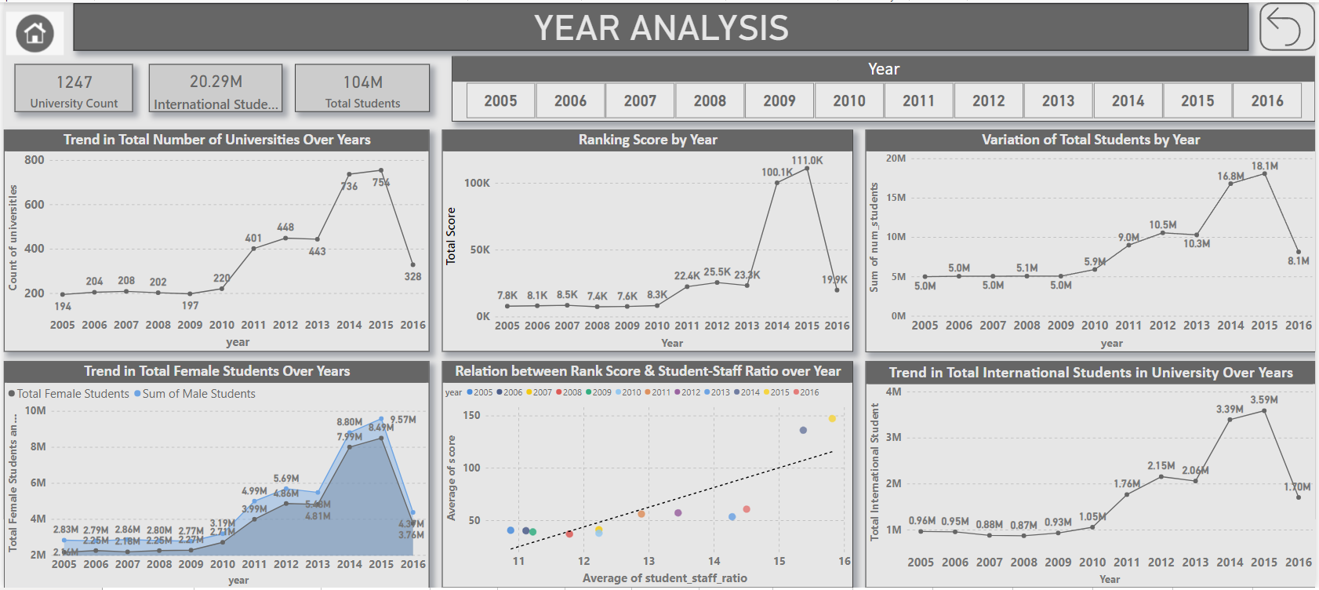

**Conclusion:**

This comprehensive analysis of university rankings, demographics, and trends across countries has provided valuable insights into the dynamic landscape of higher education. Through the utilization of Power BI, SQL, and Excel, I delved deep into the complexities of academic performance, institutional characteristics, and the evolving nature of ranking systems.

Exploration revealed a multitude of findings, including the varying distribution of universities across countries and the correlation between a student, and the number of universities. I uncovered insights into the impact of ranking criteria on university scores and the relationship between ranking systems and international, male, female students’ enrolment. Key findings include the notable concentration of universities in the United States, underlining its pivotal role in higher education. Additionally, the varying preferences of ranking systems and their distinct evaluation criteria shed light on the complexity of assessing academic institutions on a global scale.

The project also shed light on the evolving trends in university rankings over time, highlighting fluctuations in scores, criteria weights, and demographic compositions. Additionally, we explored the relationship between university ranking scores, student-staff ratios, and the percentage of female students, providing valuable insights for stakeholders in academia and beyond. The dataset also revealed intriguing patterns in student demographics, with notable trends in the enrolment of female and international students. These insights underscore the importance of creating inclusive and supportive learning environments for a diverse student body.

Overall, the analysis underscores the importance of data-driven decision-making in shaping policies, strategies, and investments in higher education. By leveraging advanced analytical tools and methodologies, we have contributed to a deeper understanding of the factors driving university success and performance on a global scale. As I conclude this project, stand poised to continue exploration of the ever-evolving landscape of higher education, armed with newfound insights and perspectives to guide future endeavours.